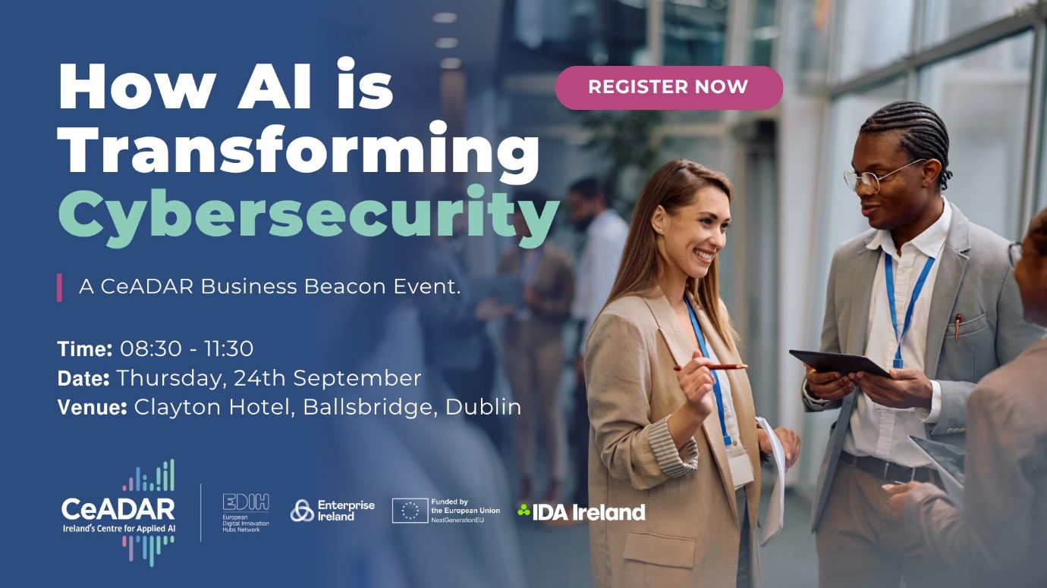
𝗝𝗼𝗶𝗻 𝗖𝗲𝗔𝗗𝗔𝗥, 𝗜𝗿𝗲𝗹𝗮𝗻𝗱’𝘀 𝗖𝗲𝗻𝘁𝗿𝗲 𝗳𝗼𝗿 𝗔𝗽𝗽𝗹𝗶𝗲𝗱 𝗔𝗜, 𝗳𝗼𝗿 𝘁𝗵𝗲𝗶𝗿 𝗕𝘂𝘀𝗶𝗻𝗲𝘀𝘀 𝗕𝗲𝗮𝗰𝗼𝗻 𝗲𝘃𝗲𝗻𝘁 𝗼𝗻 ‘𝗛𝗼𝘄 𝗔𝗜 𝗶𝘀 𝗧𝗿𝗮𝗻𝘀𝗳𝗼𝗿𝗺𝗶𝗻𝗴 𝗖𝘆𝗯𝗲𝗿𝘀𝗲𝗰𝘂𝗿𝗶𝘁𝘆’.

CeADAR’s Business Beacons provide an opportunity to network with industry, meet with the CeADAR team and gain insights into important AI topics impacting business decisions in today’s workplace.

Guest speaker this month is Dr. Valerie Lyons, Board Director and COO of BH Consulting, best selling Author of ‘The Privacy Leader Compass’ and winner of Most Inspiring Woman in Cyber 2026.

The intersection of AI and Cybersecurity is currently one of the most rapidly evolving domains in technology and Dr. Valerie Lyons will be providing critical insights and analysis on the evolving risk landscape, covering cyber security, privacy, and AI governance.

CeADAR are excited to also be hosting Glenda Deveney from Munster Technological University, who will give an overview of the Cybersecurity services available through ENTIRE EDIH Ireland's European Digital Innovation Hub programme.

𝗧𝗶𝗺𝗲: 08:30 - 11:30
𝗗𝗮𝘁𝗲: Thursday, 24th September
𝗩𝗲𝗻𝘂𝗲: Clayton Hotel, Ballsbridge Dublin

𝗬𝗼𝘂 𝗰𝗮𝗻 𝗿𝗲𝗴𝗶𝘀𝘁𝗲𝗿 𝗵𝗲𝗿𝗲: https://lnkd.in/dk8ZqZz4

Places are limited and priority is given to CeADAR Member Companies.

